**WATER MOTOR HEALTH PREDICTION**

**INTRODUCTION**

Water motors are commonly used in both industrial applications and household appliances. Water motors will play an important role in both house hold and industrial and also in agriculture sector.

Motors will pump the water from one place to another place this pumping of water by motors will depends on particular parameters which will describes the performance of Water motor. Capacity, voltage, Current, Rotational speed and temperature are some examples of parameters which will predict the performance of Water Motor. All the above parameters are independent and the performance which is depends on the independent variables.

**OBJECTIVES OF RESEARCH**

The main objective of this research is to predict the performance of the Motor .For example in a big industries a large Motors used if they are suddenly stops the working then this occurs big loss for that industry .This is due to the lack of prediction in advance .If we predict the performance of the Motor in advance we will stop the loss to the industry or at least we will decrease the loss. In not only industry but also in so many fields water Motors are used by predicting the performance we will decrease the loss to that fields.

**PROBLEM STATEMENT**

In our project we will predict the performance of the Motor by comprising the parameters like capacity, voltage, Current, Flow rate, Rotational Speed with some ranges. If the performance of the motor is good then we will represent with 1 else represents with 0.

**Industry profile**

In most of the places in the world there are thermal power stations. In the thermal power stations water is heated, turns into steam and spins a steam. Then the steam are turns into power through an electrical generator. In the process, the water are pumped by the electric motor and then spins into the turbines. Therefore, by knowing the performance of the electric motor it pumps the water and then converts into the steam and finally it generates a huge amount of power within the prescribed time which passes through many towns, cities etc.

**Literature Review**

Prediction of maintenance needs for water motor.

In our country majority of the labour force is engaged in the agricultural sector.

There are three primary reasons for this failure rate:

1.     Most handpumps are manufactured in India with poor quality controls and recycled parts.

2.   Inaccurate placement of groundwater extraction boreholes.

3.    The shortage of skilled labor for placement and maintenance.

In this literature predict the maintenance requirements of the water pumps. Accurately identifying the motors prone to failure will assist the stakeholders from the organizations to better allocate preventive and curative interventions to this issue of failure.

**DATA COLLECTION**

In our dataset there are eight variables in which 7 are independent and one is dependent. Independent variables are Flow rate, voltage, current, speed, capacity, capacity in watt. And the dependent variable is performance.

1.Flow rate will depend on the capacity of the motor

Ex: -a 1hp capacity motor will pump 80lit/min like that 0.5hp capacity motor will pump 40lit/min.

2.we can convert capacity in hp into watt

Ex: -0.5hp =372.5watt

3.Current will depend on the capacity and voltage. we can evaluate the current used by the Motor by using the below formula.

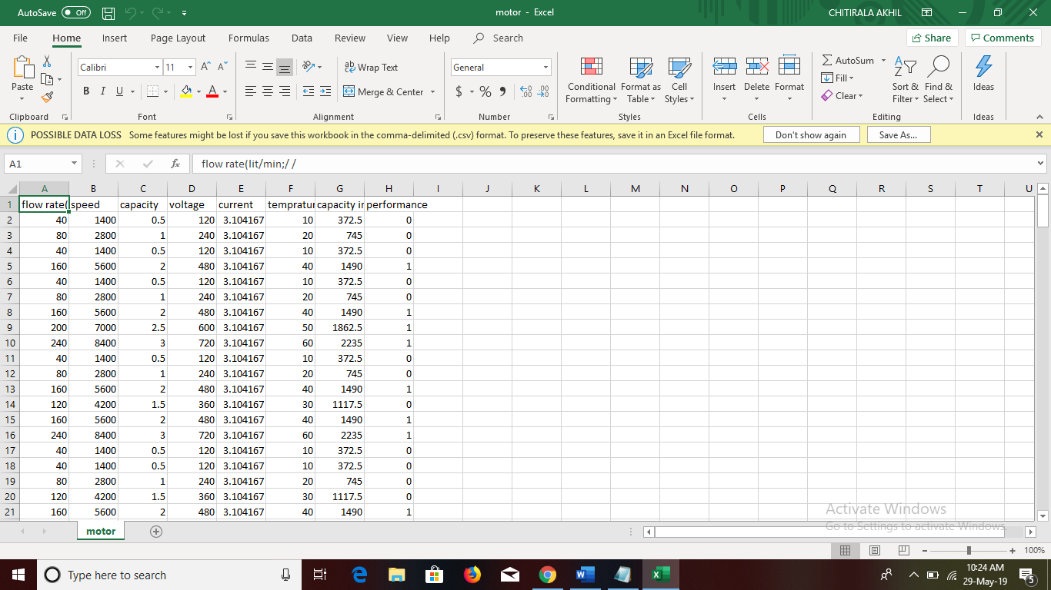

**METHADOLOGY**

**Data Analysis**

Flow rate: - Quantity of a liquid moving through a pipe or a channel within a given or standard period

Ex: - 80lit/min

Capacity: - The amount that something can produce

Ex: - 1hp, 2hp, and ½ hp

Voltage: - Voltage, also called *electromotive force*, is a quantitative expression of the potential difference in charge between two points in an electrical field.

Current: - Current is a flow of electrical charge carriers, usually electrons or electron-deficient atoms.

**Code and Output**

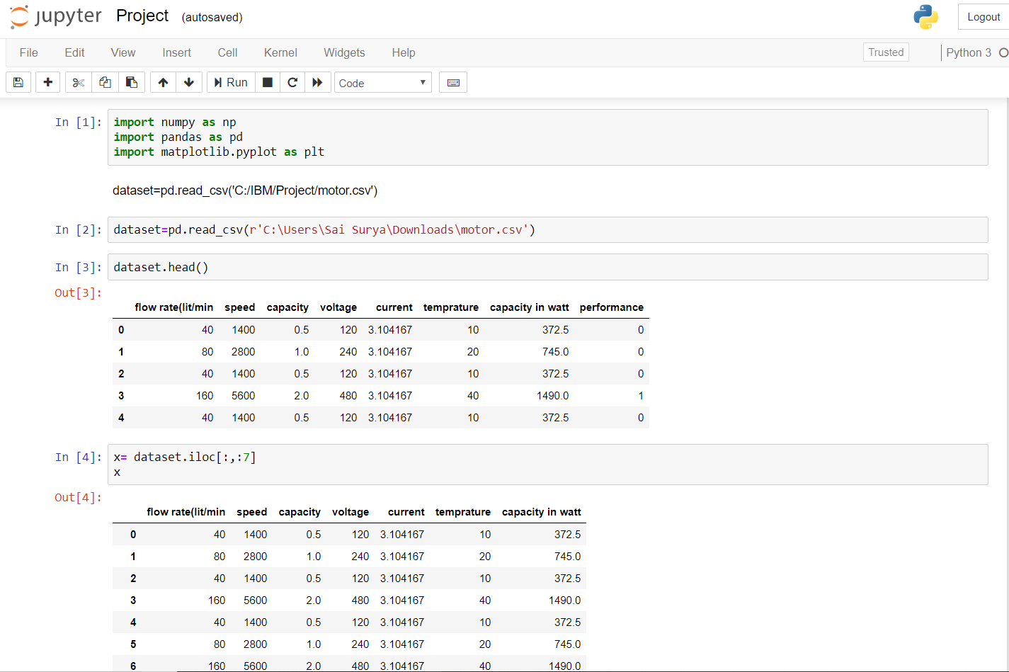

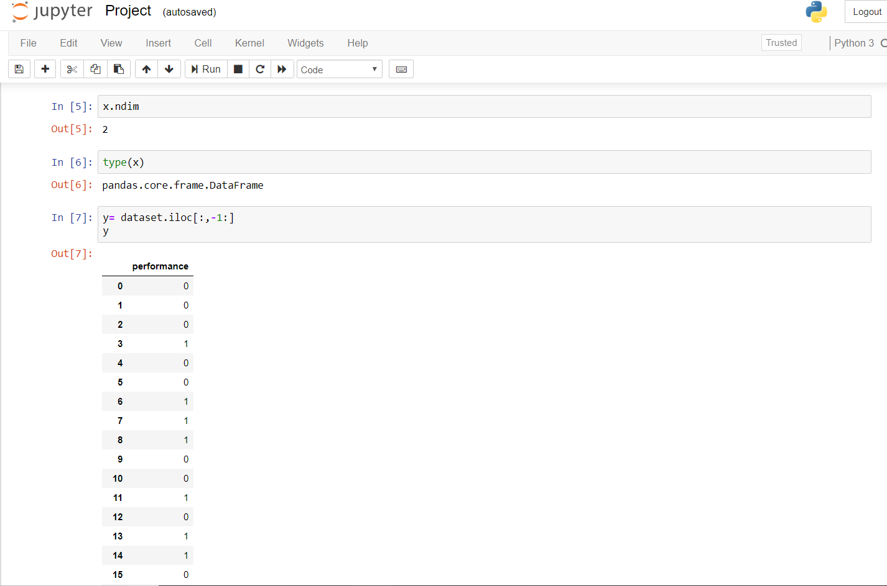

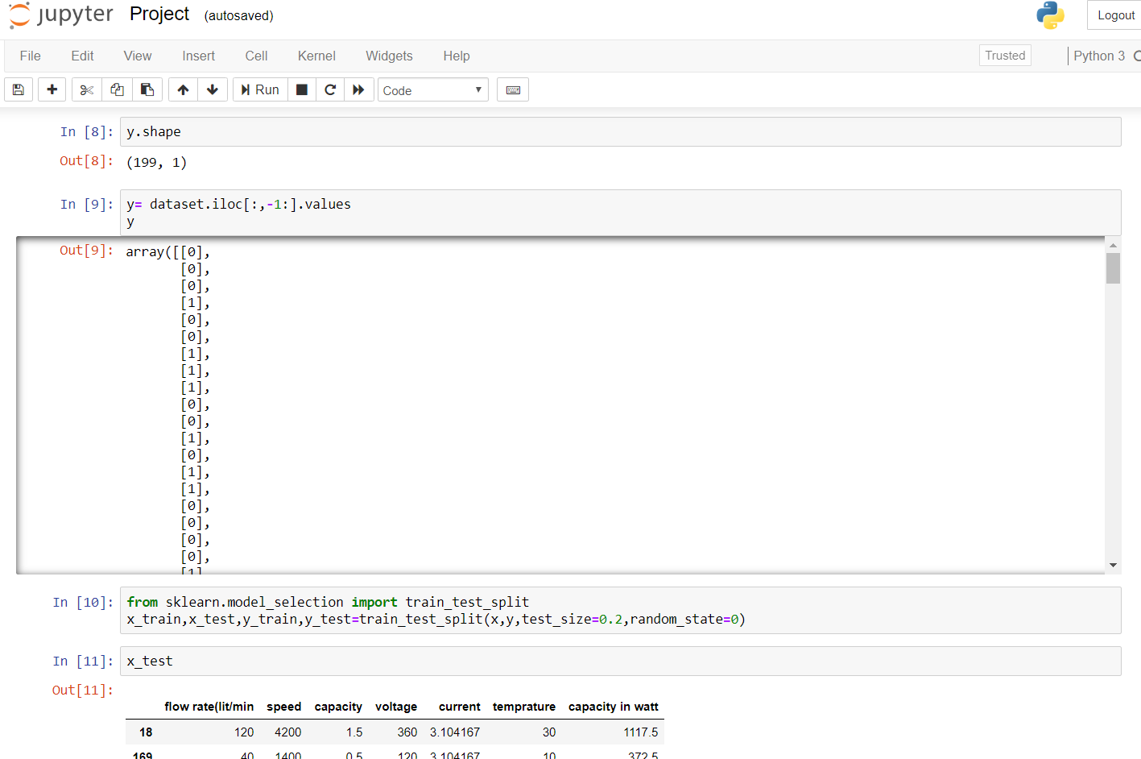

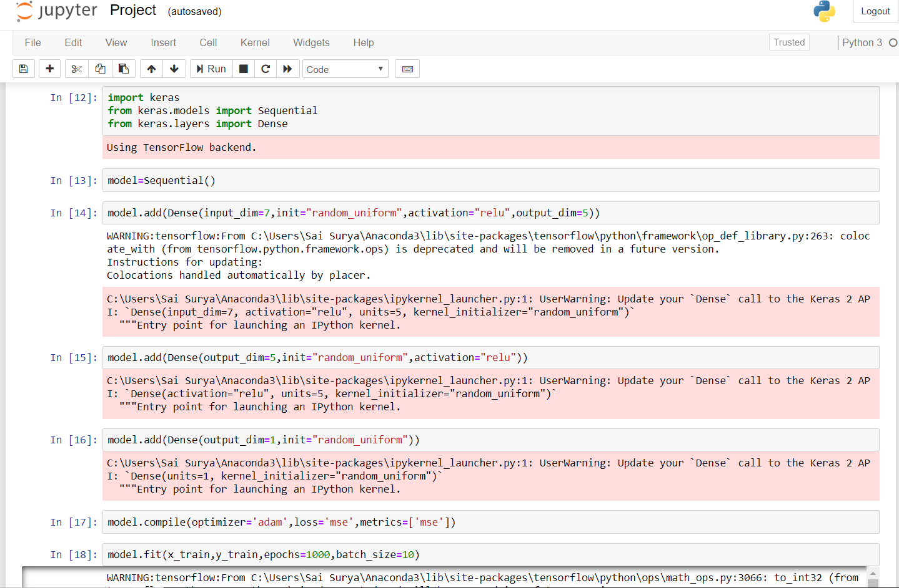

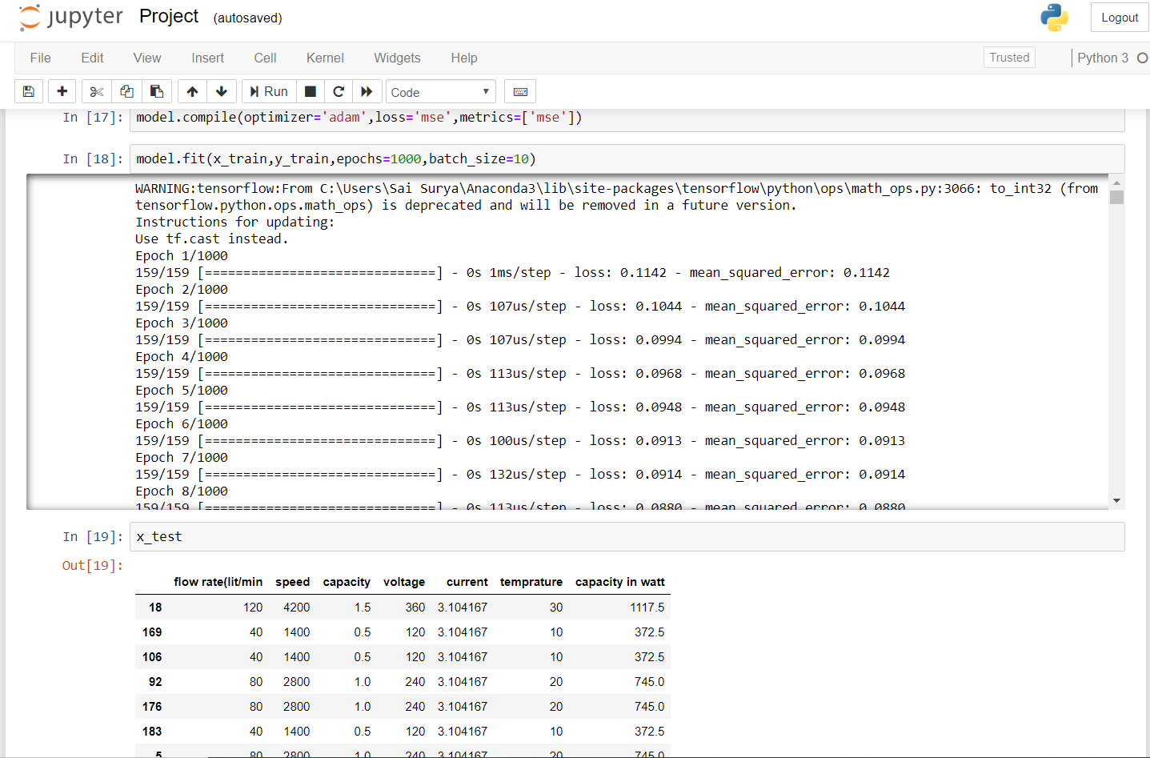

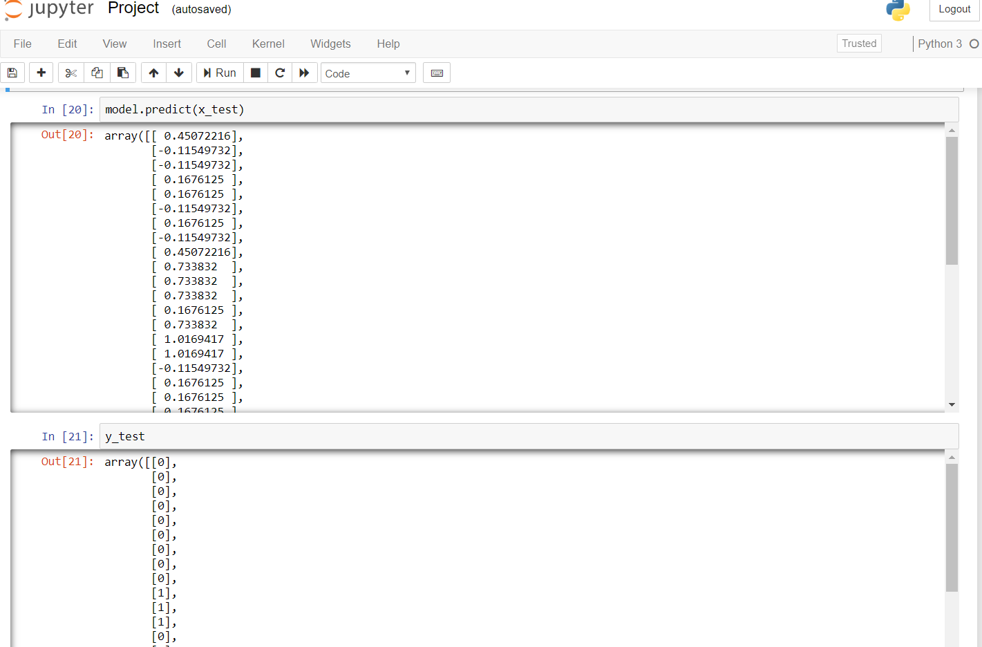

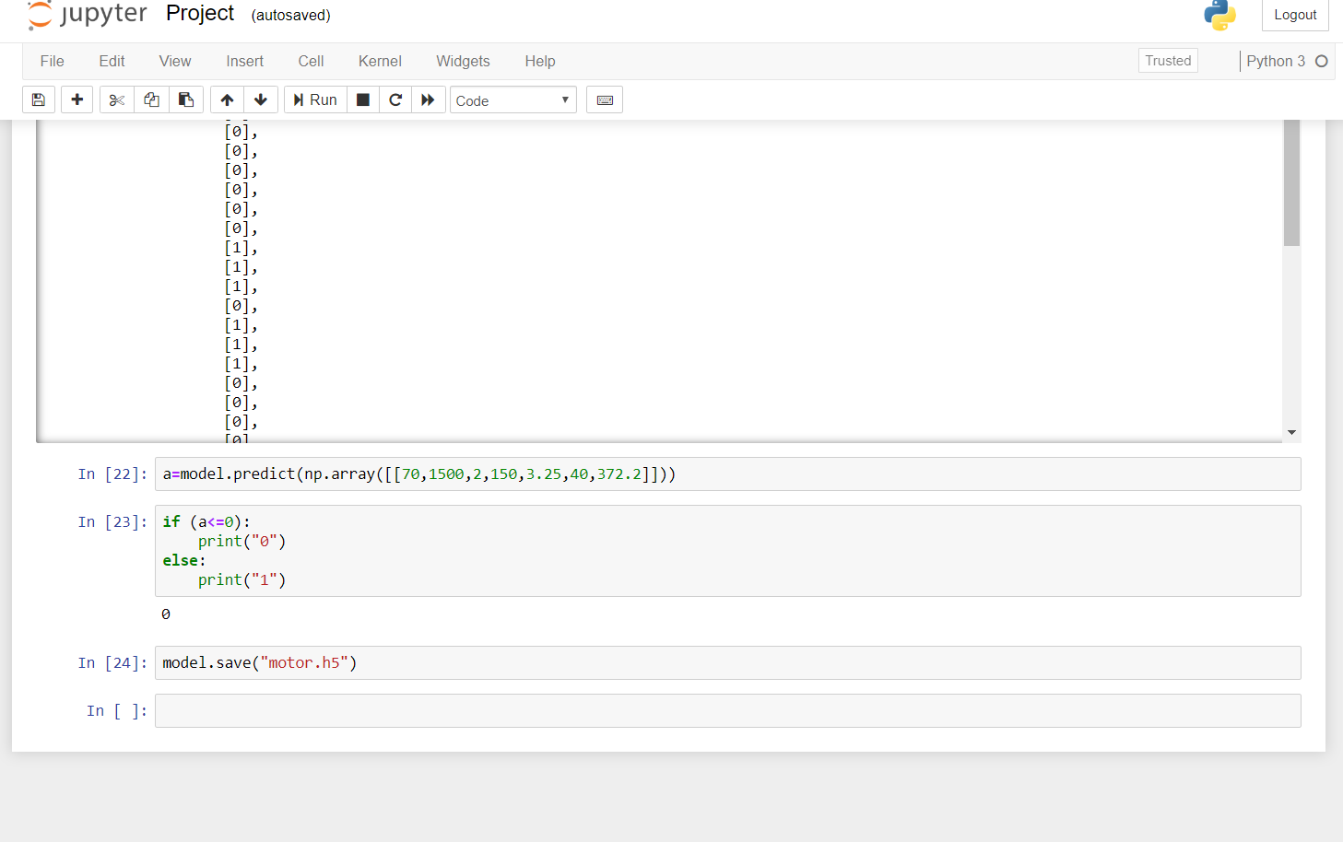

**U.I: -**

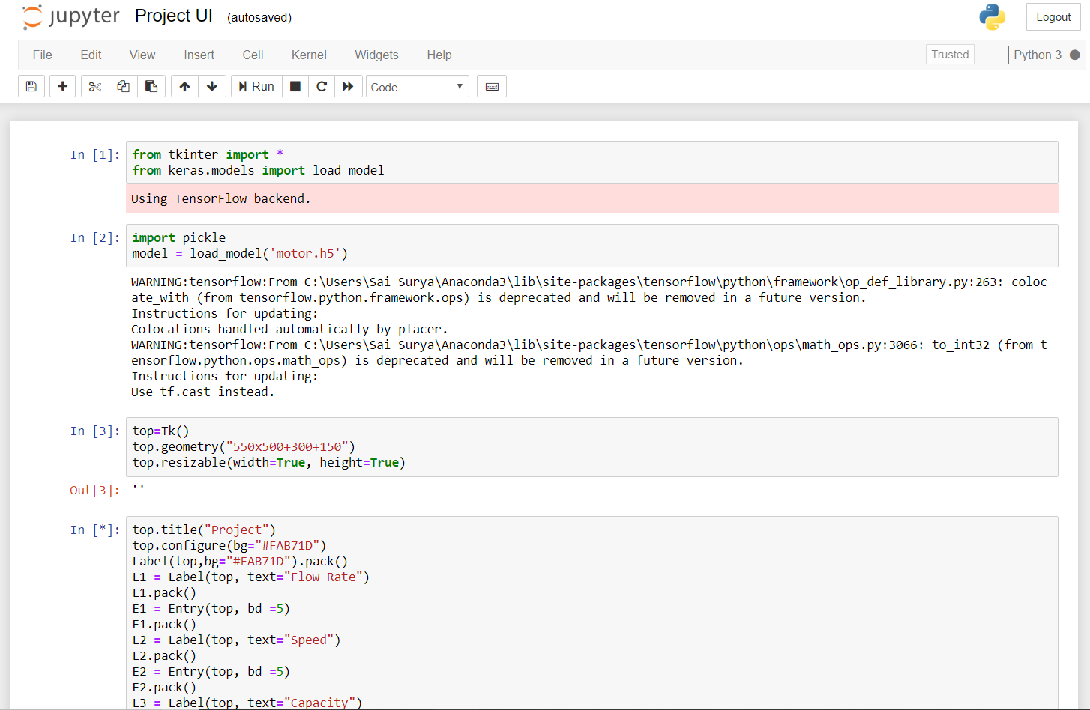

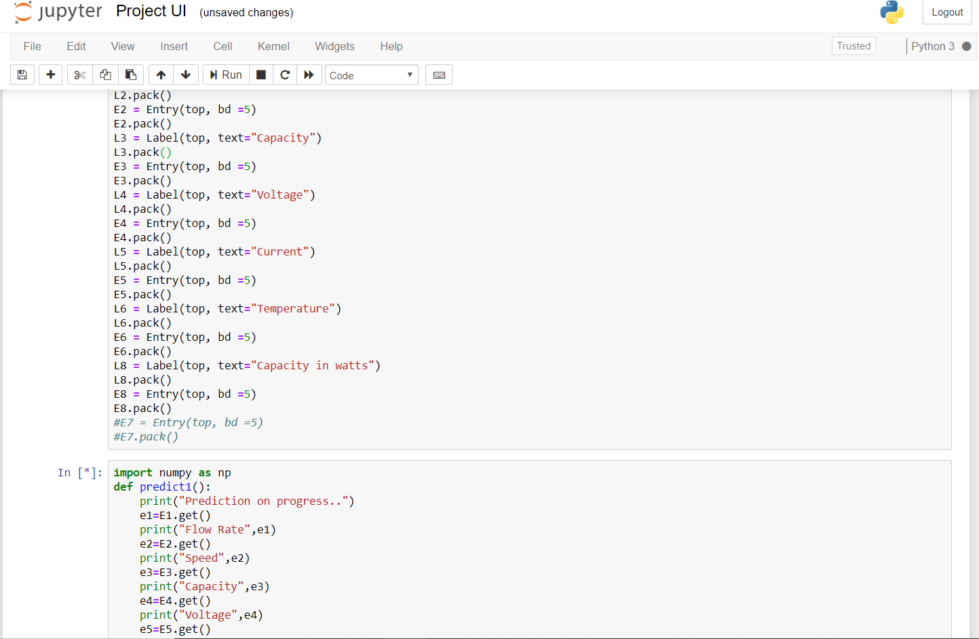

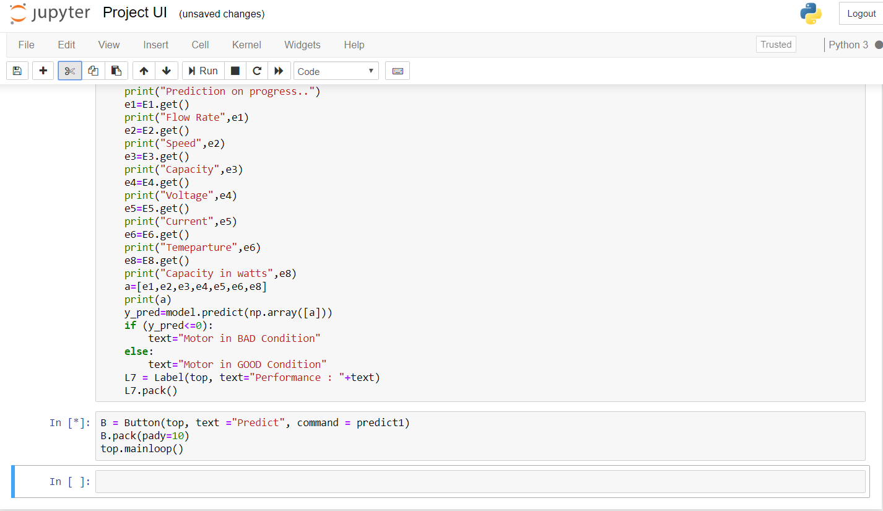

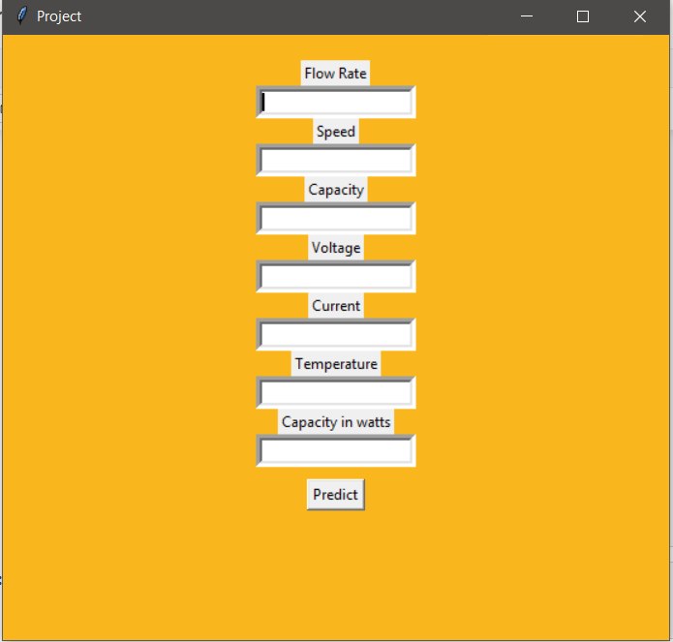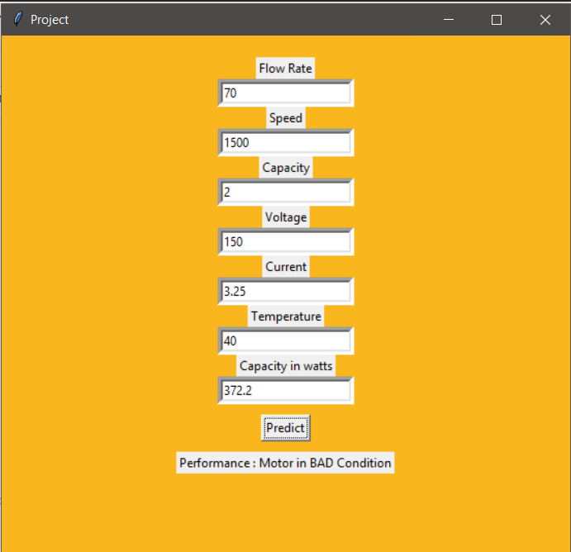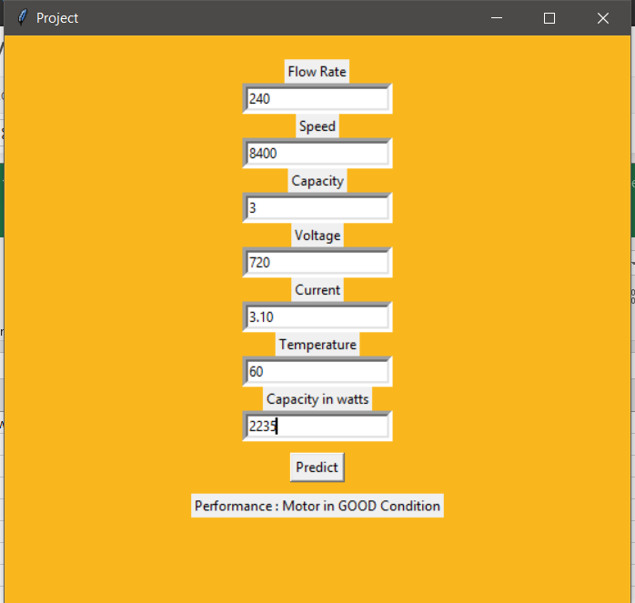

**Statistical techniques**

**ANN(Artificial neural network) :-**

**Data Preprocessing**

1. **Step** 1: Import Libraries. First **step** is usually importing the libraries that will be needed in the program. ...
2. **Step** 2: Import the Dataset. ...
3. **Step** 3: Taking care of Missing **Data** in Dataset. ...
4. **Step** 4: Encoding categorical **data**. ...
5. **Step** 5: Splitting the Dataset into Training set and Test Set. ...
6. **Step** 6: Feature Scaling.

**Steps for building model library installation**

1. Import Libraries

2.Intialize the neural network model

3.Add Input layer, weight, activation function, hidden layer

4.Add hidden layer

5.Add output layer

6.COmpile the neural network model

An Artificial Neural Network (ANN) is composed of four principal objects:

* Layers: all the learning occurs in the layers. There are 3 layers 1) Input 2) Hidden and 3) Output
* feature and label: Input data to the network(features) and output from the network (labels)
* loss function: Metric used to estimate the performance of the learning phase
* optimizer: Improve the learning by updating the knowledge in the network

A neural network will take the input data and push them into an ensemble of layers. The network needs to evaluate its performance with a loss function. The loss function gives to the network an idea of the path it needs to take before it masters the knowledge. The network needs to improve its knowledge with the help of an optimizer.

If you take a look at the figure below, you will understand the underlying mechanism.

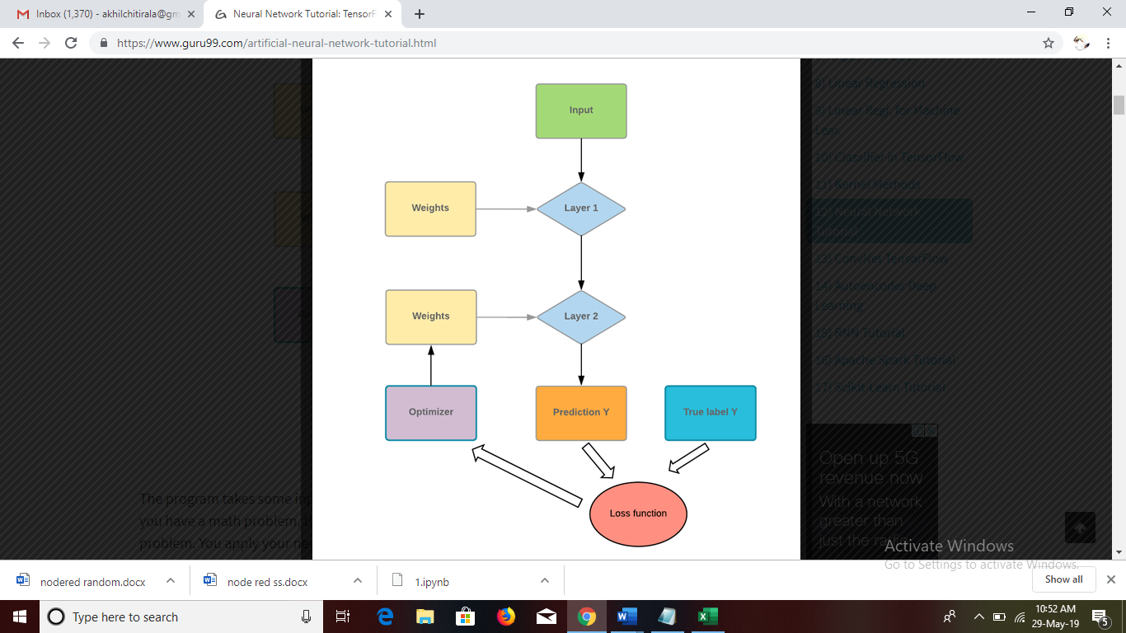

**Findings and suggestions**

In this project we find the performance of the motor by comprising the parameters like capacity, voltage, Current, Flow rate, Rotational Speed with some ranges. If output results 1- represents the motor is in good position and if output results 0-repersents the motor is going to be spoil.

We suggest to implement our project in agricultural areas, industrial purposes and various platforms such that we can reduces the future problems and also can produce the production in time. We should always shield the motor from external vibrations,  particularly when they are not working.

**Conclusion**

We conclude the performance of the motor by using the ANN methodology which comprise the seven parameters. If the performance is good, we can continue the production. If the performance is bad, it is better to change the motor to get the production within the desired time.